
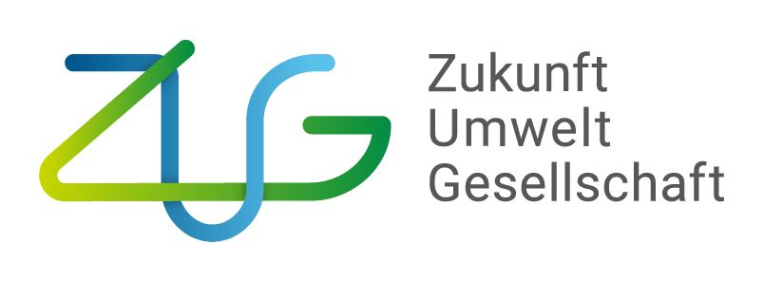

IKI Medium Grants

Amendment Request
to

IKI Office at Zukunft – Umwelt - Gesellschaft (ZUG) gGmbH

[Project title]

submitted by

[Implementing Organisation]

Place, Date:
Authorised signatory: | …………………………………………………..……  ………………………………………………………..  Name and position

Project reference number (Förderkennzeichen) | 67IMG…
Project title
Country/countries of implementation
First recipient | Name of organisation
Project duration | !selection! until !selection!
IKI grant | EUR

Please delete all explanations in grey font before submitting this form!
Amendment Requests must be submitted prior to the start of requested activities. The following deadlines for implementing organisations to submit amendment requests for timely processing have been worked out with the IKI resorts BMWK and BMUV. However, these processing times may be extended due to any necessary political and/or international legal safeguards.

Amendments with and without term extension with  a) substantive adjustments and / or  b) change of subgrant amount and/or  c) change of local partner | 6 Months
Conceptual amendments | 6 Months
Extension of project duration (without impact on funding and conceptual amendments) | 3 Months
Reallocation of funds (without conceptual amendments and change of subgrant amount ) | 3 Months
Unblocking of funds | 3 Months

Subject of the present request is/are the following change(s):
Please check the relevant box(es) below to indicate your amendments. Multiple selections are possible. Use the text box below for more detailed explanations about the necessity and appropriateness of the amendment(s) requested and to provide further relevant information,
e. g. the necessity and appropriateness of the requested increase of the project funding volume, the amount of funds to be reallocated, etc. Please also take note of the instructions in grey italics relating to the underlined expressions for further information about the completion and submission of this request.

☐ Reallocation of funds (NOT applicable to fixed-sum-financing mode): In case of exceeding the main budget lines by more than 20 per cent related to the latest approved budget, please submit an updated financing plan (incl. updated allocation of funds) at profi online as well as in Excel format. Please use the provided on the IMG website budget template. The main budget lines refer to A: the overall personnel expenditures, B: administrative expenditures, C: items over 800 EUR.]

☐ Change of the Subgrant amount [If the Subgrant amount to the Subgrantees in accordance to the grant notification (Zuwendungsbescheid) is changing, the adjustment needs to be requested. Therefore, please submit an updated financing plan (incl. updated allocation of funds) at profi online as well as in Excel format. Please use the provided budget template on the IMG website.]

☐ Unblocking of funds [An unblocking of funds is only necessary if specifically stipulated in the grant notification (Zuwendungsbescheid). To request an unblocking of funds, the thus individually agreed requirements of the grant notification shall be fulfilled by the First Recipient. Please add the agreed documents for unblocking the funds to the amendment request.]

☐ Extension of project duration (without impact on funding)
Requested project duration: !selection! until !selection!
[The extension of the project duration shall guarantee the achievement at the outcome/ output level without exceeding the agreed project funding volume.]

☐ Change of local partner (subgrantee)
[If the forwarding grants to the subgrantees in accordance to the grant notification (Zuwendungsbescheid) is changing, the adjustment needs to be requested. Therefore, please add an updated financing plan (incl. updated allocation of funds) at profi online as well as in Excel format. Please use the provided budget template on the IMG website.]

☐ Conceptual amendment(s) [This refers to amendments related to the outcome and output level and corresponding indicators. Amendments at the activity level do not need an official approval of the IKI Office, as long as they do not affect the project goals and/or have been declared as significant activities in the grant notification (Zuwendungsbescheid) and/or do not require any additional funding. However, for information purposes, the informal notification to the IKI Office about any amendments at the activity level is necessary before starting their implementation. Please contact the IKI Office for further details regarding the submission of additional documents.]

☐ Project cancellation [Premature end of funding for an ongoing IMG project or termination during the approval phase if a termination criterion occurs that cannot be corrected by a change (amendment request) to the impact logic, duration or other central content of the project proposal. ]

☐ Other

Justification for the necessity and appropriateness of your amendment request:
[Please indicate below the current project status and the reasons for the amendment request. Please do not write more than 4,000 characters incl. spaces.]

